Drugs

Glucogel – Applied to patient’s gums and gently rubbed in. Used mainly for the treatment of low blood sugar diabetes but safe for use on anyone, e.g. an unconscious illness patient where the cause of unconsciousness is unknown.

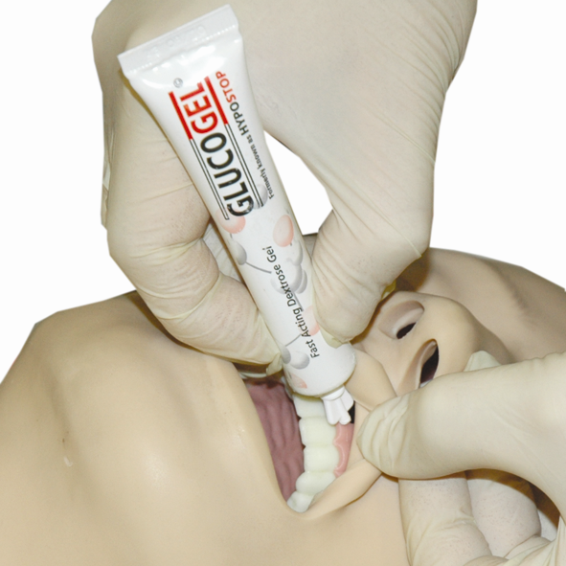

Glycerol Trinitrate (GTN) – Given ONLY for treatment of non-traumatic cardiac chest pain (Card 5), as it opens blood vessels to increase blood flow to the heart. One spray is given under the tongue, and this can be repeated five minutes later if the patient is still suffering with pain.

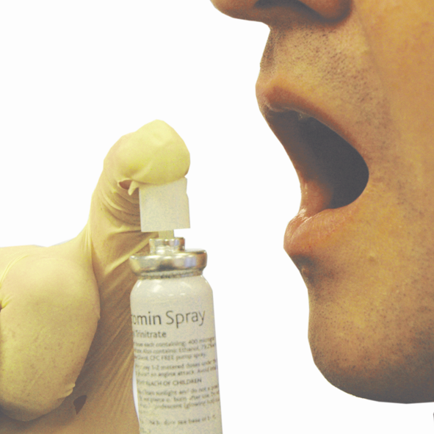

Aspirin – Given ONLY for treatment of non-traumatic cardiac chest pain (Card 5). It is given if the patient has had pain for over ten minutes, providing the patient is over 16 years old, is not allergic to aspirin and is not on heparin or warfarin as they are also blood thinning drugs. The patient must chew tablet.

Kwells – To be given for cases of sea sickness as can help decrease signs and symptoms. Must only be given to over 10 year olds and is chewed or sucked.

Paracetamol – Used only in cases of heat exhaustion as instructed by the dose on the packet, and is swallowed with a glass of water. It helps to lower body temperature which is important in heat exhaustion where patient will be suffering raised body temperatures.

